Bug fix 1.0.

To apply the fix of the bug, follow the following procedures.

- Download the “Check-up Business Solution.zip” and “Database schema update.zip” from http://jhunexjun.hostei.com/check-up/.
- Unzip the 2 files to your desired location by right-clicking it.
- Go to “C:\Program Files\Check-up\” or maybe it is located in “D:\Program Files\Check-up\”.
- Overwrite your current “Check-up Business Solutions.exe” with the unzipped file having the same filename.

Then after that

- Open “SQLYog Community” which can be found in your Start > All Programs.

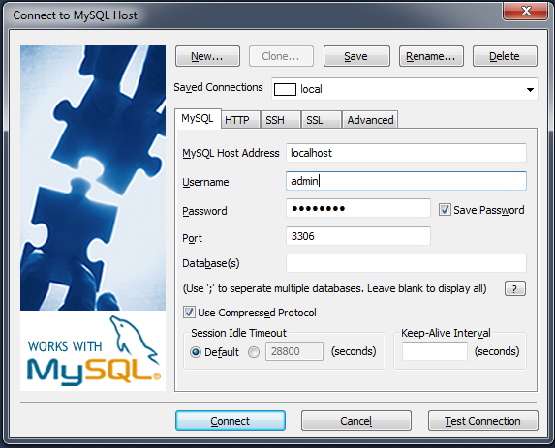

- If it doesn’t have username and password type in “admin” and “c43ckup2014” as your password. Click Connect button. You will be logged in.
- On the left side pane, click “check-up05102014”.
- Then open the downloaded and unzipped file “update_0schema.sql”. Copy the entire text and paste it to the right side white pane.

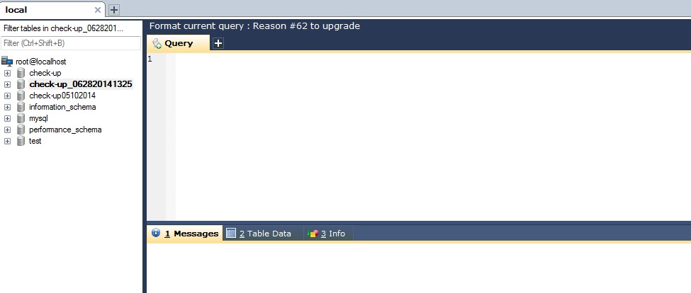

- Highlight the entire text with pressing “CTRL+A” in your keyboard then press “F9”.
- Wait until it finished running.
- Once finished, at the lower right pane under the tab “Messages” copy the entire message and send it to jdream_catcher@yahoo.com – my email address.

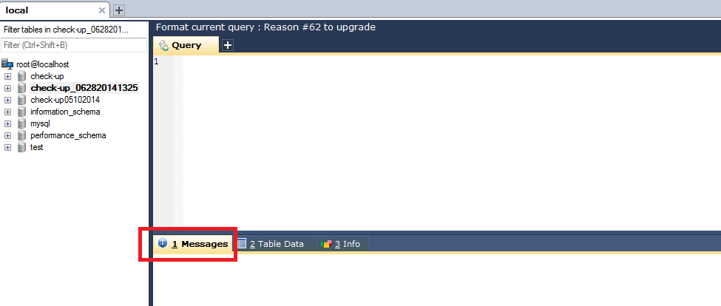
- You must be done. Run the application and check if the amounts have now been corrected.

